# CTO Fantasy Game

# Premise

You have just accepted the role as Chief Technology Officer (CTO) at a software development organisation. The organisation comes with existing teams, projects and practices. It’s your job to guide and develop the software development practices at the organisation with the aim of making it a competitive, efficient company, producing quality software with a loyal and dedicated team. All within budget, of course.

Most sources (*give examples) describing the introduction of Agile practices into an organisation assume that we will be starting with a baseline of Waterfall existing at the organisation, but nowadays this is rarely the case. It’s far more likely that everyone in the organisation has some knowledge and experience of Agile, but little or no training and very often the Agile practices and their functions will be misunderstood and misapplied. Similarly, DevOps and QA practices will usually exist in some form and degree of quality.

The introduction of Aglie practices is also assumed to always be a positive process, but the existing practices, knowledge and level of acceptance of Agile can have an impact on this.

## Gameplay

As CTO, it will be your role to make decisions about the technology and software development practices used at the organisation, to make changes and/or influence others to make changes. The changes you make may be explicit, such instigating a company-wide 80% code coverage threshold, or implicit, such as improving the level of software knowledge by encouraging weekly Tech Talks.

Throughout the game there will be opportunities for you to discover new practices and choose whether to try to use them, for example, learning about 3 Amigos sessions by sending a Scrum Master to an Agile conference.

Much of the organisation state will be hidden from you, and you will need to infer how things are going by indirect means, such as the number of bugs, number of customer complaints or employee churn rate.

## Game Mechanics

My initial thoughts on game mechanics are to represent all of the organisation’s attributes as a set of properties, each with a value between 0 and 1. Some of these attributes can be directly manipulated by the player, while others are calculated dynamically from other attributes.

An outline of some possible attributes and their relationships:

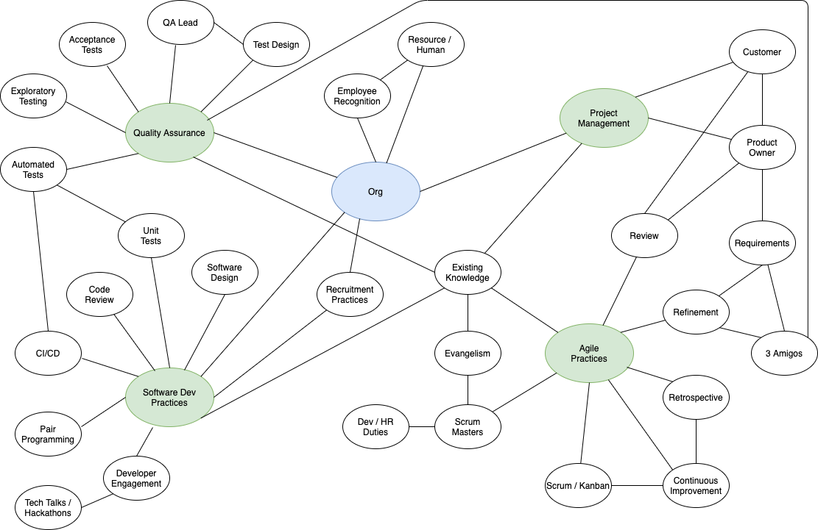

## Game Development

Initially, the game will be developed using React/Redux for rapid development, with an isometric visual representation of the organisation/office and game state in Phaser. The React/Redux portions could be ported to Phaser later if necessary. All of this should ensure that the game can be played on any device, and be easily ported to a mobile app.

## Other Thoughts

The game could include a difficulty level choice at the start, triggered by which company the CTO chooses to accept a job offer from, “DinoTech” for a more Waterfall company with distinct Dev and Ops (for example).

## Next Steps

* Build the game skeleton and get it functioning with just one or two attributes.
* Investigate existing research into:
  + Agile transformations
  + QA practices
  + Software development practices
* Implement uncontrollable variability.
* Storyline for gameplay